Program or Unit Name
DOWNED WOODY DEBRIS/FIRE EFFECTS MONITORING PLOTS HANDBOOK

This handbook is designed as a quick reference for fire effects monitoring protocol on the Huron-Manistee.
The sampling design is based on James K. Brown’s “Handbook for Inventorying Downed Woody Material” (GTR-INT16, 1974), the National Park Service’s “Fire Effects Monitoring Handbook,” and field experience.

Manistee NF Plot Standards:
ACTION / MEASURMENT | DISCRIPTION | FORM # | FORM LOCATION.
Plot Location Data Sheet | Used when establishing a new plot location. | Enter # here | Enter Location Here
Plot Protocols | Used when establishing a new plot protocols. | Enter # here | Enter Location Here
Forest Plot Fuels Inventory Data Sheet | Used for collecting fuels inventory data for calculating Fuel Loading. | Enter # here | Enter Location Here
Photographic Record Sheet | Used for photo plots. | Enter # here | Enter Location Here
Tree Mortality Monitoring Data Sheet | Used for collecting over-story data to help determine mortality | Enter # here | Enter Location Here

Archiving Data:
The Data collection sheets are turned in to the Enter person or position here. The data is then entered into Fuels Measurement Spread Sheet. It is VERY important that the information be legible and consistent.

After the data is entered the date should be documented in the lower left corner of the data sheet and then archived in the Fuels Folder if using paper copies or in the proper electronic folder.
Before leaving the office:

- Establish your sampling grid based on desired percent of stand sampled. It is very important to know the location of a starting point. All other plot locations will be referenced from the first plot.
- Make enough copies of plot data sheets.
- Fill in header information on plot data sheets with as much information as possible (compartment and stand numbers, fire history).
- If you using a compass with declination make a note of declination used on plot data sheets.
- Make sure GPS datum is forest standard or make note of one used if unsure.
- Double check equipment list.
Equipment needed:

Permanent stakes (1 for each plot) | 50´ measuring tapes (in tenths of a foot)
GPS | Compass
Rulers | Plot data sheets
Tablet w/ charger | Pen / pencils
DBH tape | Camera or tablet for photo plots
Coordinates of plots | Plastic bags for plant collection
Clip board | 20 basal area prism
flagging | Water / radio/ food / clothes

After arriving at plot center, record the coordinates in D° M” S.S” lat/long with the Datum set to WGS84 on the GPS. Also note the stand and compartment information (Figure 1).  Install the1st transect to the north by extending the measuring tape out to 35’.  Indicate the “Burn Status” to show if it is a pre-burn or post-burn measurement.  Place a permanent marker (stake, wire flag) at plot center. Measuring tapes should be laid out in the four Cardinal directions from plot center.  Record the length of transects for time lag fuels, and the azimuth and slope for each transect.  Transect lengths Diameter of debris  Downed material 0-1 in 1-3 in >3 in  Nonslash (naturally fallen material) 1-3 ´ 5-10 ´ 10-15 ´  Discontinuous light slash 1 ´ 5 ´ 10 ´  Continuous heavy slash 1 ´ 3 ´ 10 ´  Record the number of intercepts for each time lag fuel class.  For the 1000+ fuels, a diameter and species is recorded for each intercept. The 1000+ fuels are also classified as “sound” or “rotten” and recorded in the appropriate column. If a species cannot be identified, note pine or hardwood.  Tally.  Record the number of intercepts using a “dot / box method” for speed. Each dot is 1 intercept and each line connecting a dot is 1 intercept. So a box with an X in it is 10 intercepts. Then document the total in the smaller space below.  Tally rules for fuel classes:  - Only downed, dead woody material from trees and shrubs on the litter layer are recorded. Do not record:  Leaves cones bark flakes needles grass forbs undisturbed stumps  dead stems or branches still attached to standing trees or shrubs  - Only record the 1-, 10-, and 100-hr fuels along the prescribed length of the transect (1-hr from 0-3´).  - If a piece intersects the tape measure more than once, count all intercepts.  - If the end of a piece intersects the taper, only record it if the central axis is crossed.  - Estimate the diameter of rotten logs that fallen apart by visualizing a cylinder to contain the material.  - Downed material can be sample up to any height, so be sure to look up from the ground. An upper cutoff of 6´ can be used; adjust as necessary in heavy slash.  - Record diameters of 1000+ fuels to the nearest whole inch. | Plot ID: _______________________________ Coordinates:____________________________ B/C (Circle One) Date: ______/______/______  Burn Unit: _____________________________ Recorders: _____________________________  Burn Status: Circle one and indicate number of times treated, e.g., 01-yr01, 02-yr01  00-PRE____Post ____ -yr01____-yr02____-yr05____-yr10____-yr20 Other:____-yr;____-mo_____  Transect lengths, in feet: 0-.025”______0.25-1”_____1-3”______3+s_____3+r_____  Transect 1 # of intercepts Diameter (in) Litter and Duff Depths (in)  Azimuth ________° 3+s 3+r  Slope _____% 0-.25” (1-hr) .25-1” (10hr) 1-3” (100hr) (1000hr) L D L D  □ ● ● ● ● ● ● ● ● ● ● 1 1.5 .25 25  5 30  10 35  15 40  13 7 3  20 45  Litter and duff are also recorded at set intervals along the length of each transect (Figure 4).  The first measurement is taken 5 “ from the plot center and the next at the 15´ mark. Additional measurements can be taken every 5 feet, ending at the 25´ mark if you need additional data.  Tally rules for litter and duff:  - Record duff and litter measurements after fuel intercepts have been tallied.  - Record both litter and duff to the nearest .25 inch.  - Litter is still recognizable as its former self before death (it still looks like a needle).  - Duff is the decomposed litter (it is no longer recognizable as a needle).  - When stumps, logs and trees occur at the points of measurement, offset 1´ perpendicularly to the right.  - Measure through rotten logs whose central axis is in the duff layer.
Replace this figure with local protocols
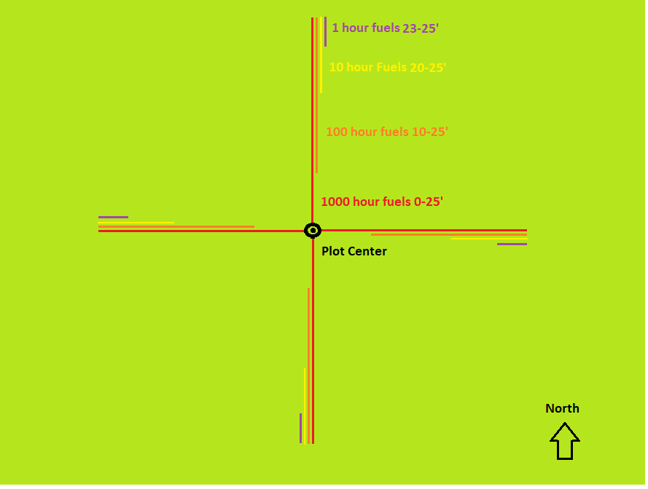

Figure 1. Plot layout

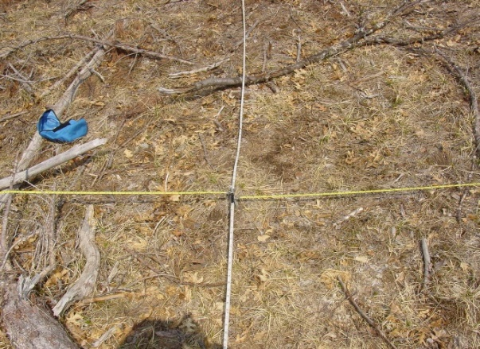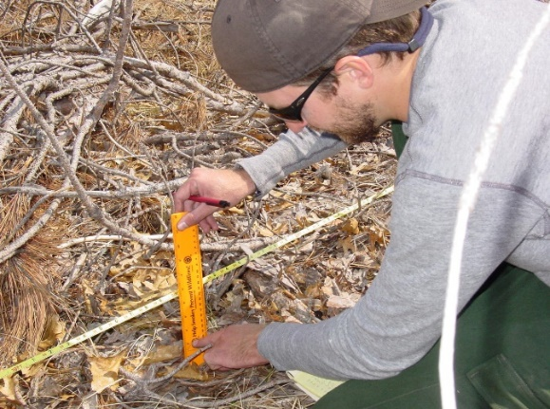

Figure 2. Lay out of four transects at 90°or 120 Figure 3. Using a ruler to measure duff and
angles. litter.

To sample the overstory using a 20 basal area prism, start by facing north and hold the prism over the plot center.
- Start in a clockwise direction looking at each tree through the prism, if the offset overlaps then record the tree (See figure 1 for more information).
- Record DBH and species for all tallied trees.
- Estimate height of char along trunk (Char is the black staining on the trunk that rubs off)
- Estimate percentage of crown scorch on the tree bole (look at browned needles, curled leaves and burned buds and twigs).

Tree mortality monitoring starts from the center of the plot. A 20 BA prism is used to determine the trees that will be measured. The measurements start at true north and then proceeds in a clockwise manner numbering each tree “from north” that the prism identifies as a large enough tree.

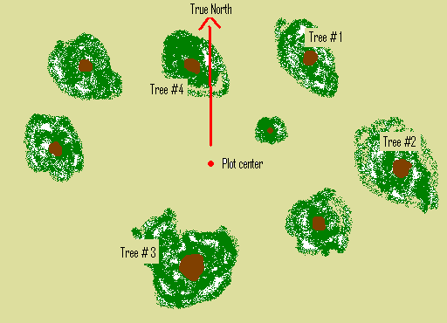 | 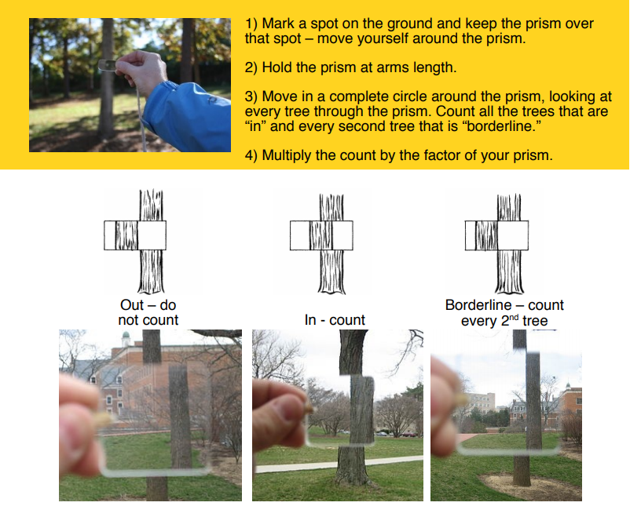

Photo plot protocols:
- Start from the center of the plot and set the camera 3 feet above the ground facing true north.
- Use the dry erase board to include the project name, date, plot #, Pre or Post and direction and position the board in the lower right corner of the photo or edit the photo on your tablet.
- Get at least 2/3 of the photo with the surface fuels and the remaining 1/3 can be above the horizon.

Example of a photo plot.
